**ICP-1 3rd Task (Repository Creation)**

1) I have already created an account in GitHub.

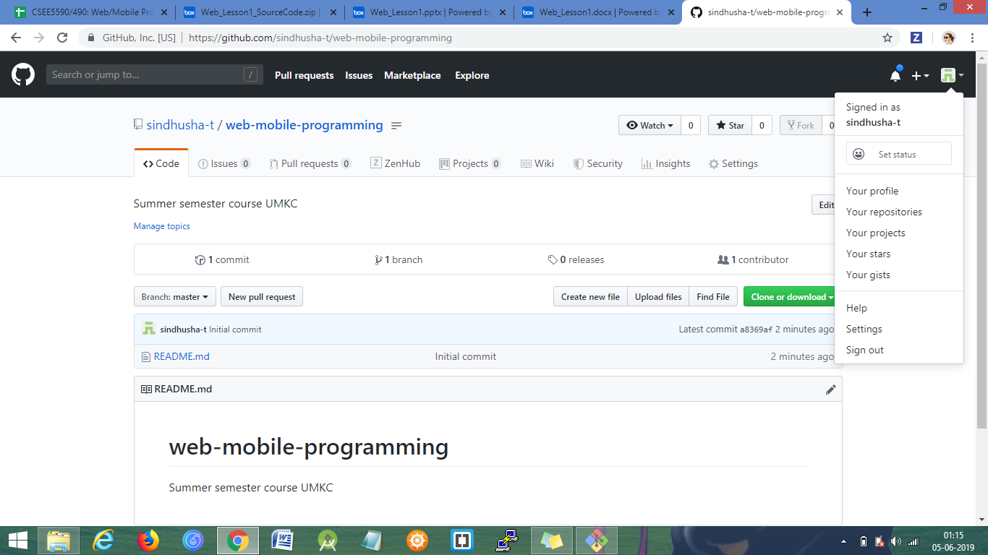

2) After creating the github account – I have created a repository with web/mobile programming repository name.

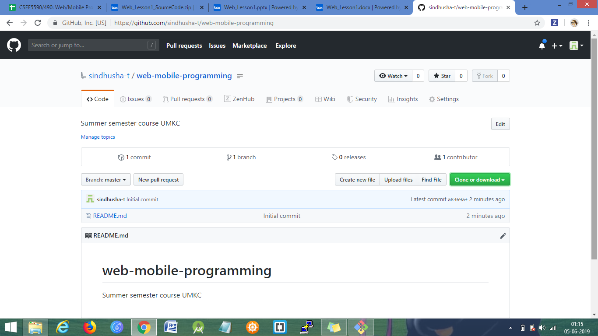

3) I have cloned the remote repository in the local repository using GIT bash.

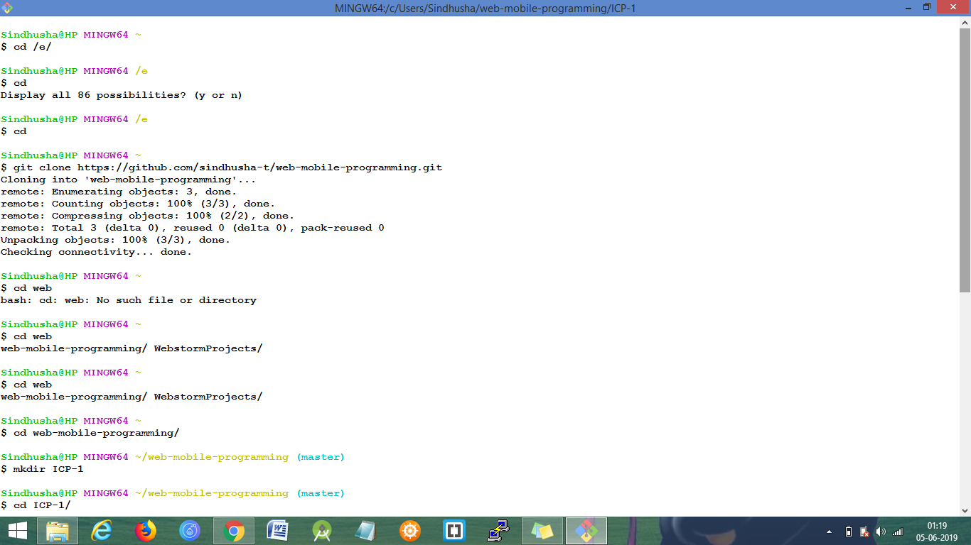

4) I have created ICP-1 folder and source and documentation folder in the local repository using GIT bash.

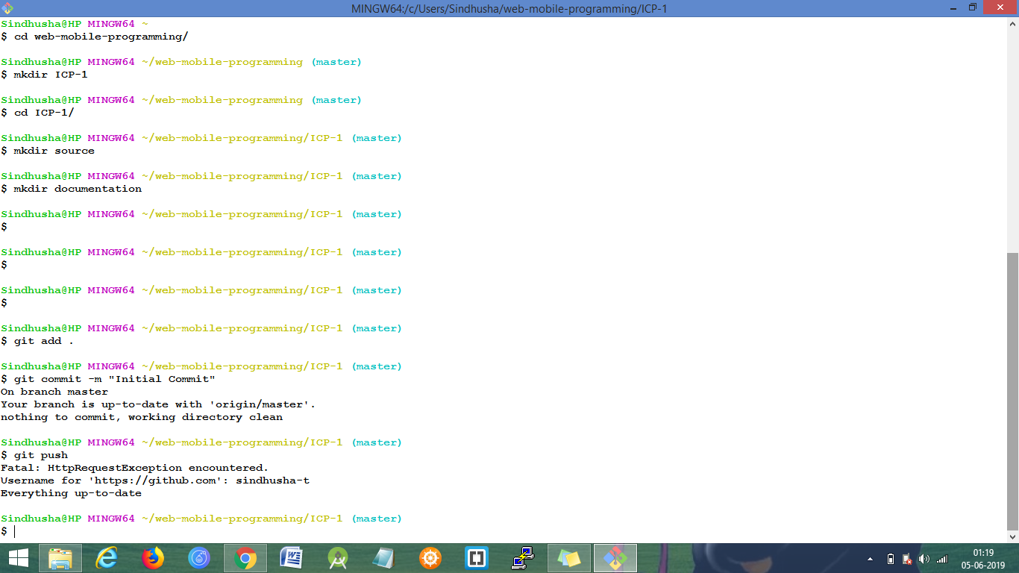

5) Installed web storms.

Downloaded Web storm from <https://www.jetbrains.com/webstorm/> and installed in the local device.

